Lab 03 Instructions:
- Download code from BbLearn
  - Create Folder of same structure : as explained in the class
- Follow the circuit set-up with two sample acquisition.
- Performing calibration:
  - Potentiometer pendulum is pre-calibrated.
    - Use slope and intercept provide, you collected last week.
  - 4 point calibration for accelerometer
    - Write down mean voltage displayed on the Figure window.
    - Remember to change filename every time for your calibration
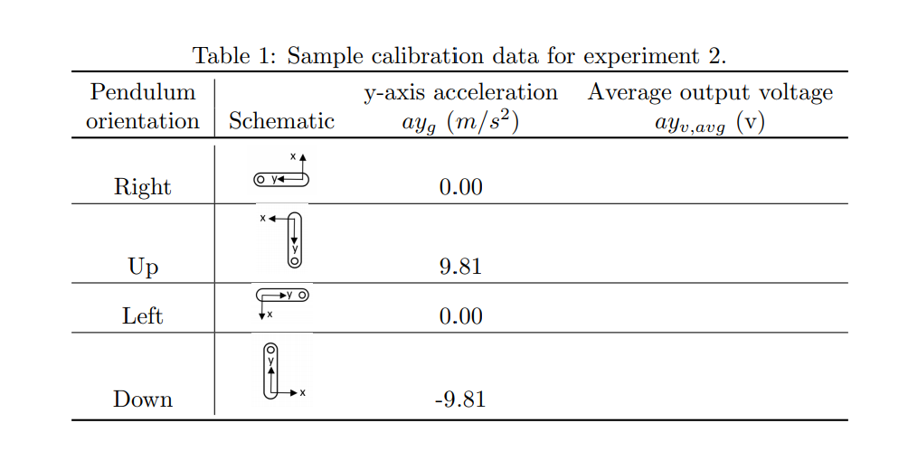
- Estimate slope and intercept (Use the Calibration Plotting Code)
- Perform pendulum normal acceleration experiment
  - Check calibration is done properly (need both calibration of potentiometer and accelerometer, you should see same acceleration values as in table for the corresponding orientations )
  - Release from -90 or 90 degs and collect acceleration and pendulum angle data.
  - Check the data file for accuracy
- Post lab
  - Submit Acceleration Calibration Plot
  - Plot of Normal Acceleration
  - Discrete derivative of potentiometer?
  - Accelerometer vs. calculation of acceleration from pendulum angular data?
    - Do they work the same?
    - Noise?

